2.      **Student Club Information**:

o    Club Logo:

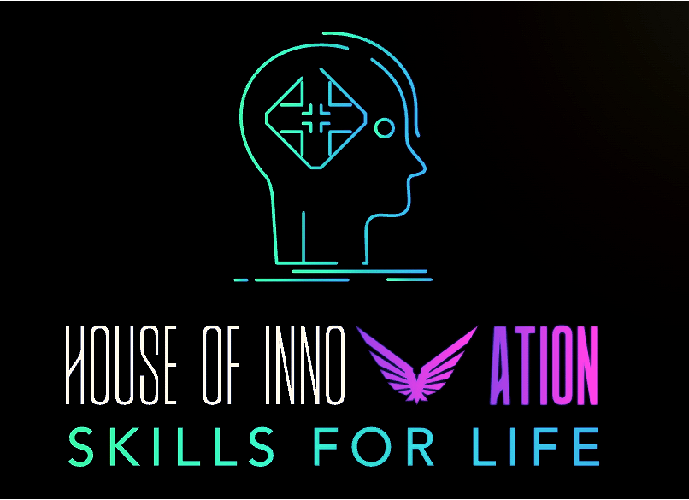

o    Name of the Club : Club House of Innovation - Skills for life

o    Total number of student participants till date: 42

o    Club Logo:



o    Name of the Club: SAEINDIA Collegiate club of CSPIT

o    Total number of student participants till date: 250+